Source: http://www.tnnhazara.org/dailynews_18-01-2012D.htm
Newspaper: Daily Awaz circulated by Hazara NGO, Tanzeem Nasl-e Nau Hazara Mughal.

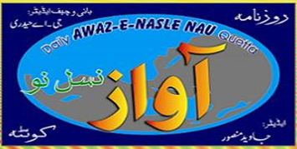


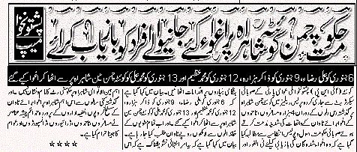

Translation:
A press release issued by the provincial secretariat of the Pushtunkwah Milli Awami Party has fully condemned the abductions [for ransom] of the four (4) Hazara passengers/businessman on the Quetta-Chaman (border to Afghanistan) highway and has demanded from the Local Governemnt (of Balochistan) and Police to take urgent measures under Emergency orders for the safe recovery of the Hazaras.
According to Pushtunkwah press statement, Ali Raza was abducted on January 6, Zakir Hazara on January 9, Mohammad Azeem on January 12, and Mohammad Ali on January 13, from Quetta-Chaman highway, and now a heavy ransom (hundreds of thousands of Rupees) is demanded from their loved ones. Statement showed extreme concern for the complete void of security on Quetta-Chaman national highway, and observed an increase in the cases of abductions for ransom by armed terrorists and terrorists groups under the supervision of the Pakistan’s Security Agencies , that have made life a living-hell for the innocent passengers, drivers, and transporters for the past several years.

